# Tugas Pemrograman Berorientasi Objek



**Muhamad Salman Adhim Baqy**

**A11.2020.12641**

**Fakultas Ilmu Komputer**

**Program Studi Teknik Informatika**

**Universitas Dian Nuswantoro**

**2022**

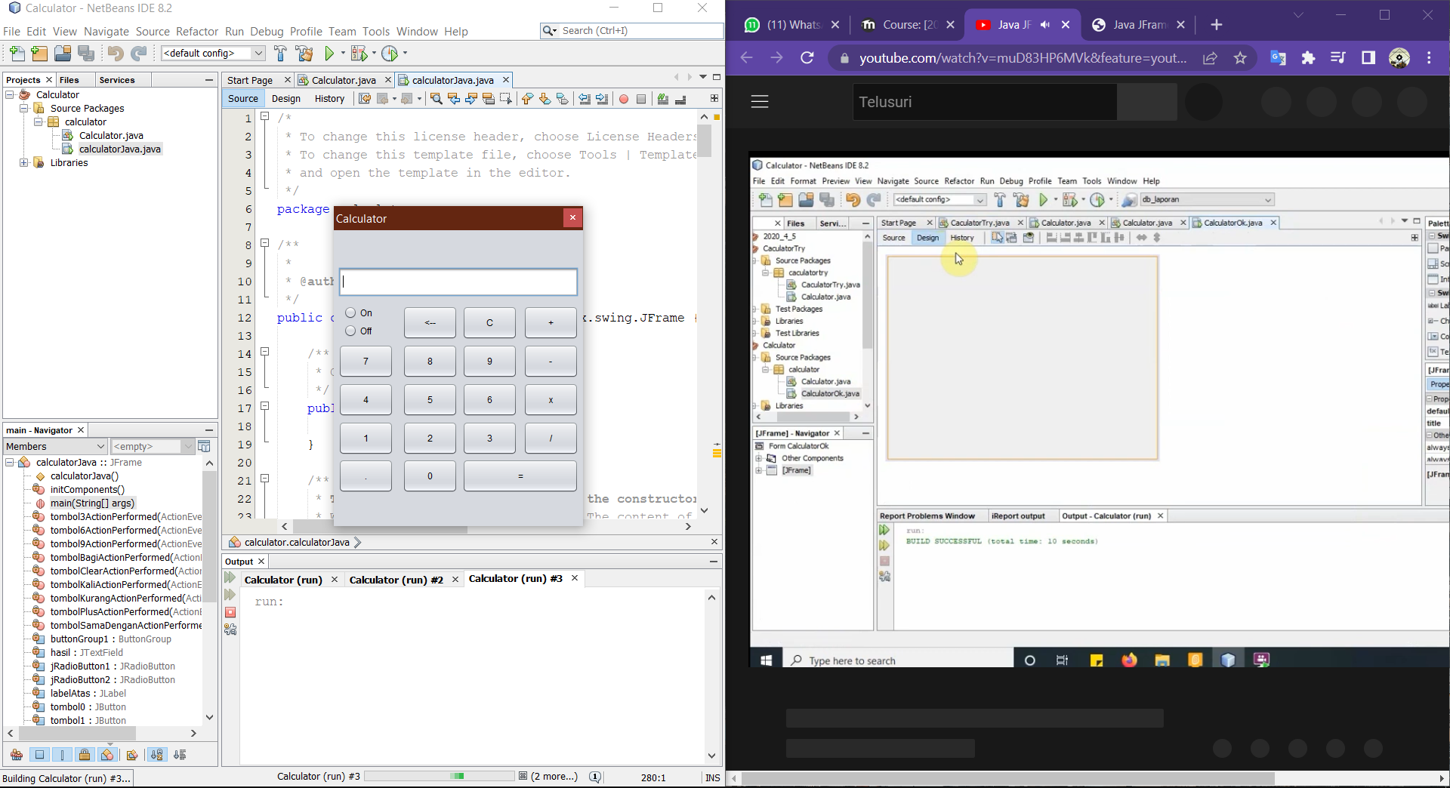Hasil

Source Code

calculatorJava.java

Container dan Fungsi Aritmatik

|  |
| --- |
| double angka, jawaban;  char simbol;  public calculatorJava() {  initComponents();  tombolOn.setEnabled(false);  hasil.setEditable(false);  }    private void operasi_aritmatika(){  switch(simbol){  case '+':  jawaban = angka + Double.parseDouble(hasil.getText());  hasil.setText(Double.toString(jawaban));  break;  case '-':  jawaban = angka - Double.parseDouble(hasil.getText());  hasil.setText(Double.toString(jawaban));  break;  case 'x':  jawaban = angka * Double.parseDouble(hasil.getText());  hasil.setText(Double.toString(jawaban));  break;  case '/':  jawaban = angka / Double.parseDouble(hasil.getText());  hasil.setText(Double.toString(jawaban));  break;  }    } |

Fungsi Tombol

|  |
| --- |
| private void tombolClearActionPerformed(java.awt.event.ActionEvent evt) {  // TODO add your handling code here:  hasil.setText("");  }  private void tombolPlusActionPerformed(java.awt.event.ActionEvent evt) {  // TODO add your handling code here:  //hasil.setText(hasil.getText() + " + ");  angka = Double.parseDouble(hasil.getText());  simbol = '+';  labelAtas.setText(angka + " + ");  hasil.setText("");  }  private void tombol9ActionPerformed(java.awt.event.ActionEvent evt) {  // TODO add your handling code here:  hasil.setText(hasil.getText() + "9");  }  private void tombolKurangActionPerformed(java.awt.event.ActionEvent evt) {  // TODO add your handling code here:  //hasil.setText(hasil.getText() + " - ");  angka = Double.parseDouble(hasil.getText());  simbol = '-';  labelAtas.setText(angka + " - ");  hasil.setText("");  }  private void tombol6ActionPerformed(java.awt.event.ActionEvent evt) {  // TODO add your handling code here:  hasil.setText(hasil.getText() + "6");  }  private void tombolKaliActionPerformed(java.awt.event.ActionEvent evt) {  // TODO add your handling code here:  //hasil.setText(hasil.getText() + " x ");  angka = Double.parseDouble(hasil.getText());  simbol = 'x';  labelAtas.setText(angka + " x ");  hasil.setText("");  }  private void tombol3ActionPerformed(java.awt.event.ActionEvent evt) {  // TODO add your handling code here:  hasil.setText(hasil.getText() + "3");  }  private void tombolBagiActionPerformed(java.awt.event.ActionEvent evt) {  // TODO add your handling code here:  //hasil.setText(hasil.getText() + " / ");  angka = Double.parseDouble(hasil.getText());  simbol = '/';  labelAtas.setText(angka+ " / ");  hasil.setText("");  }  private void tombolSamaDenganActionPerformed(java.awt.event.ActionEvent evt) {  // TODO add your handling code here:  operasi_aritmatika();  labelAtas.setText("");  }  private void tombol7ActionPerformed(java.awt.event.ActionEvent evt) {  // TODO add your handling code here:  hasil.setText(hasil.getText() + "7");  }  private void tombol8ActionPerformed(java.awt.event.ActionEvent evt) {  // TODO add your handling code here:  hasil.setText(hasil.getText() + "8");  }  private void tombol4ActionPerformed(java.awt.event.ActionEvent evt) {  // TODO add your handling code here:  hasil.setText(hasil.getText() + "4");  }  private void tombol5ActionPerformed(java.awt.event.ActionEvent evt) {  // TODO add your handling code here:  hasil.setText(hasil.getText() + "5");  }  private void tombol1ActionPerformed(java.awt.event.ActionEvent evt) {  // TODO add your handling code here:  hasil.setText(hasil.getText() + "1");  }  private void tombol2ActionPerformed(java.awt.event.ActionEvent evt) {  // TODO add your handling code here:  hasil.setText(hasil.getText() + "2");  }  private void tombolTitikActionPerformed(java.awt.event.ActionEvent evt) {  // TODO add your handling code here:  hasil.setText(hasil.getText() + ".");  }  private void tombol0ActionPerformed(java.awt.event.ActionEvent evt) {  // TODO add your handling code here:  hasil.setText(hasil.getText() + "0");  }  private void tombolOnActionPerformed(java.awt.event.ActionEvent evt) {  // TODO add your handling code here:  tombol1.setEnabled(true);  tombol2.setEnabled(true);  tombol3.setEnabled(true);  tombol4.setEnabled(true);  tombol5.setEnabled(true);  tombol6.setEnabled(true);  tombol7.setEnabled(true);  tombol8.setEnabled(true);  tombol9.setEnabled(true);  tombol0.setEnabled(true);  tombolPlus.setEnabled(true);  tombolPanah.setEnabled(true);  tombolKurang.setEnabled(true);  tombolKali.setEnabled(true);  tombolBagi.setEnabled(true);  tombolClear.setEnabled(true);  tombolTitik.setEnabled(true);  tombolSamaDengan.setEnabled(true);  tombolOff.setEnabled(true);  tombolOn.setEnabled(false);  }  private void tombolOffActionPerformed(java.awt.event.ActionEvent evt) {  // TODO add your handling code here:  tombol1.setEnabled(false);  tombol2.setEnabled(false);  tombol3.setEnabled(false);  tombol4.setEnabled(false);  tombol5.setEnabled(false);  tombol6.setEnabled(false);  tombol7.setEnabled(false);  tombol8.setEnabled(false);  tombol9.setEnabled(false);  tombol0.setEnabled(false);  tombolPlus.setEnabled(false);  tombolPanah.setEnabled(false);  tombolKurang.setEnabled(false);  tombolKali.setEnabled(false);  tombolBagi.setEnabled(false);  tombolClear.setEnabled(false);  tombolTitik.setEnabled(false);  tombolSamaDengan.setEnabled(false);  tombolOff.setEnabled(false);  tombolOn.setEnabled(true);  }  private void tombolPanahActionPerformed(java.awt.event.ActionEvent evt) {  // TODO add your handling code here:  int length = hasil.getText().length();  int number = hasil.getText().length()-1;  String store;    if(length > 0){  StringBuilder back = new StringBuilder(hasil.getText());  back.deleteCharAt(number);  store = back.toString();  hasil.setText(store);  }  } |